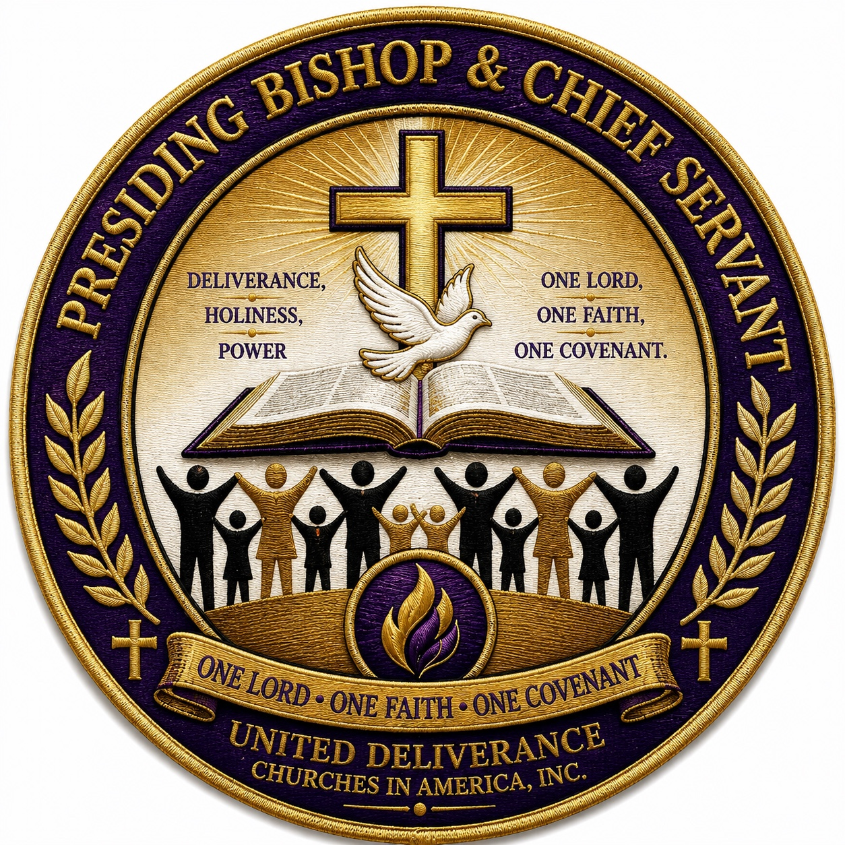
UNITED DELIVERANCE CHURCHES IN AMERICA, INC.
OFFICIAL CHURCH DIRECTORY
2026 National Edition
Regional Leadership & Active Churches Edition

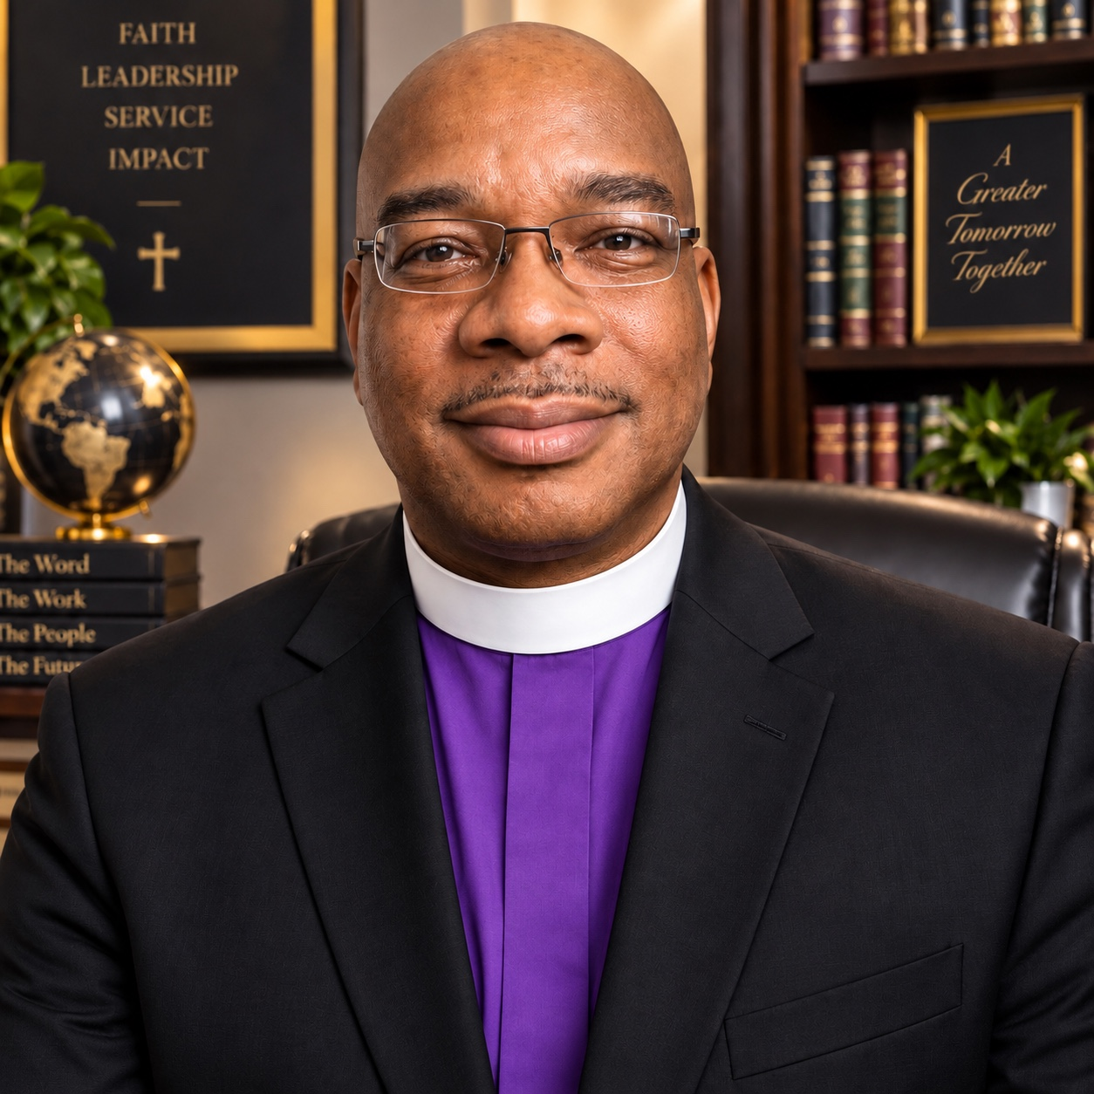
The Very Reverend Charles Paige
Presiding Bishop & Chief Servant
One Lord • One Faith • One Covenant
www.udcanational.org
A Covenantal Connection of Independent Deliverance, Holiness & Deliverance-Holiness Congregations

A Message from the Presiding Bishop & Chief Servant
Grace and peace to you in the name of our Lord Jesus Christ.
With gratitude, prayerful expectation, and covenantal purpose, I present this Regional Edition of the Official Church Directory of the United Deliverance Churches in America, Inc. This directory is more than a compilation of names and locations. It is a witness to a broad and enduring stream of Deliverance, Holiness, and Deliverance-Holiness ministry serving communities across our nation.
Independent churches have often carried significant spiritual and community responsibilities without the benefit of a consistent connectional forum. Our congregations preach Christ, strengthen families, minister to the hurting, develop leaders, serve neighborhoods, and preserve a testimony of holiness, deliverance, and the transforming power of God.
UDCA exists to help create meaningful connection without diminishing local church autonomy. We seek cooperation without coercion, communion without control, and representation without the surrender of local identity. Our conviction is simple: independent churches need not be isolated churches.
The regional format in this directory is designed to make connection practical. It allows neighboring states - especially those with only one or two identified churches - to participate within a broader regional family for fellowship, communication, prayer, leadership development, and outreach.
May this directory help us know one another better, strengthen the ties of covenant among us, and prepare the way for one voice, one connection, and one communion of churches serving Christ together.
Independent, but not isolated. Autonomous, but connected.
Distinct congregations, sharing one table, one conversation, and one connection.

In covenant and Christian service,
The Very Reverend Charles Paige
Presiding Bishop & Chief Servant
United Deliverance Churches in America, Inc.

Bishops & Apostles Leadership Registry
The following Bishops and Apostles are listed from the current active church directory where those titles are explicitly identified in the church leadership record.
Connectional Office | Presiding Bishop & Chief Servant
Leader | The Very Reverend Charles Paige

Title | Name | Church | City / State | Region | Contact
Bishop | Bobby Hilton | Word of Deliverance Ministries for the World, Inc. | Forest Park, OH | Great Lakes & Midwest | 513-851-9673  info@wordofdeliverance.org
Bishop | Avery Austin | Total Deliverance Ministry | Philadelphia, PA | Mid-Atlantic | (267) 639-4698
Bishop | Chance Sr | Antioch Outreach and Deliverance Ministry | Wayne, PA | Mid-Atlantic | (484) 588-0448  antiochoutreachministries1@gmail.com
Bishop | Samuel L. Carruth | Holy Light Church of Deliverance | Portsmouth, VA | Mid-Atlantic | 757-397-4424  holylightva@gmail.com
Bishop | O'Neal A. Christie | Power and Mercy Deliverance Ministries | East Hartford, CT | Northeast | (866) 212-3623  nealchristie@gmail.com
Bishop | Herbert Smith | God's Hospital Deliverance Holiness Church | Dallas, TX | South Central & Gulf | 214-942-0074  bishopsmith340@tx.rr.com
Bishop | Willie Watson Jr | The Real Praise Temple Church. A Deliverance Ministry. | Bartow, FL | Southeast | 863-533-9332
Bishop | Donald Johnson | Faith and Deliverance Ministries | Mableton, GA | Southeast | 678-451-0180
Apostle | Richard Taylor | New Day Deliverance Holiness Church | Houston, TX | South Central & Gulf | 713-633-5011  nddhc@newdaychurch.org

Regional Directory Structure
For directory and connectional purposes, the active churches are organized into six geographic regions. This format combines smaller state fields with neighboring states while preserving each congregation's state identity.
Region | States / Territories | Churches | Purpose
Northeast Region | CT (8), MA (2), RI (1), NY (9) | 20 | Regional fellowship, communication, outreach, and support.
Mid-Atlantic Region | NJ (3), PA (14), MD (6), VA (6), WV (1) | 30 | Regional fellowship, communication, outreach, and support.
Southeast Region | NC (12), SC (2), GA (12), FL (12) | 38 | Regional fellowship, communication, outreach, and support.
South Central & Gulf Region | AL (9), TN (4), KY (1), LA (1), TX (13), OK (1) | 29 | Regional fellowship, communication, outreach, and support.
Great Lakes & Midwest Region | OH (2), MI (9), IN (1), IL (2), WI (1), MN (1) | 16 | Regional fellowship, communication, outreach, and support.
West & Pacific Region | CA (4), ID (1), MT (1), WA (1), GU (1), MP (1) | 9 | Regional fellowship, communication, outreach, and support.

Total active churches in the regional directory: 142
Bishops and Apostles identified in active church records: 9

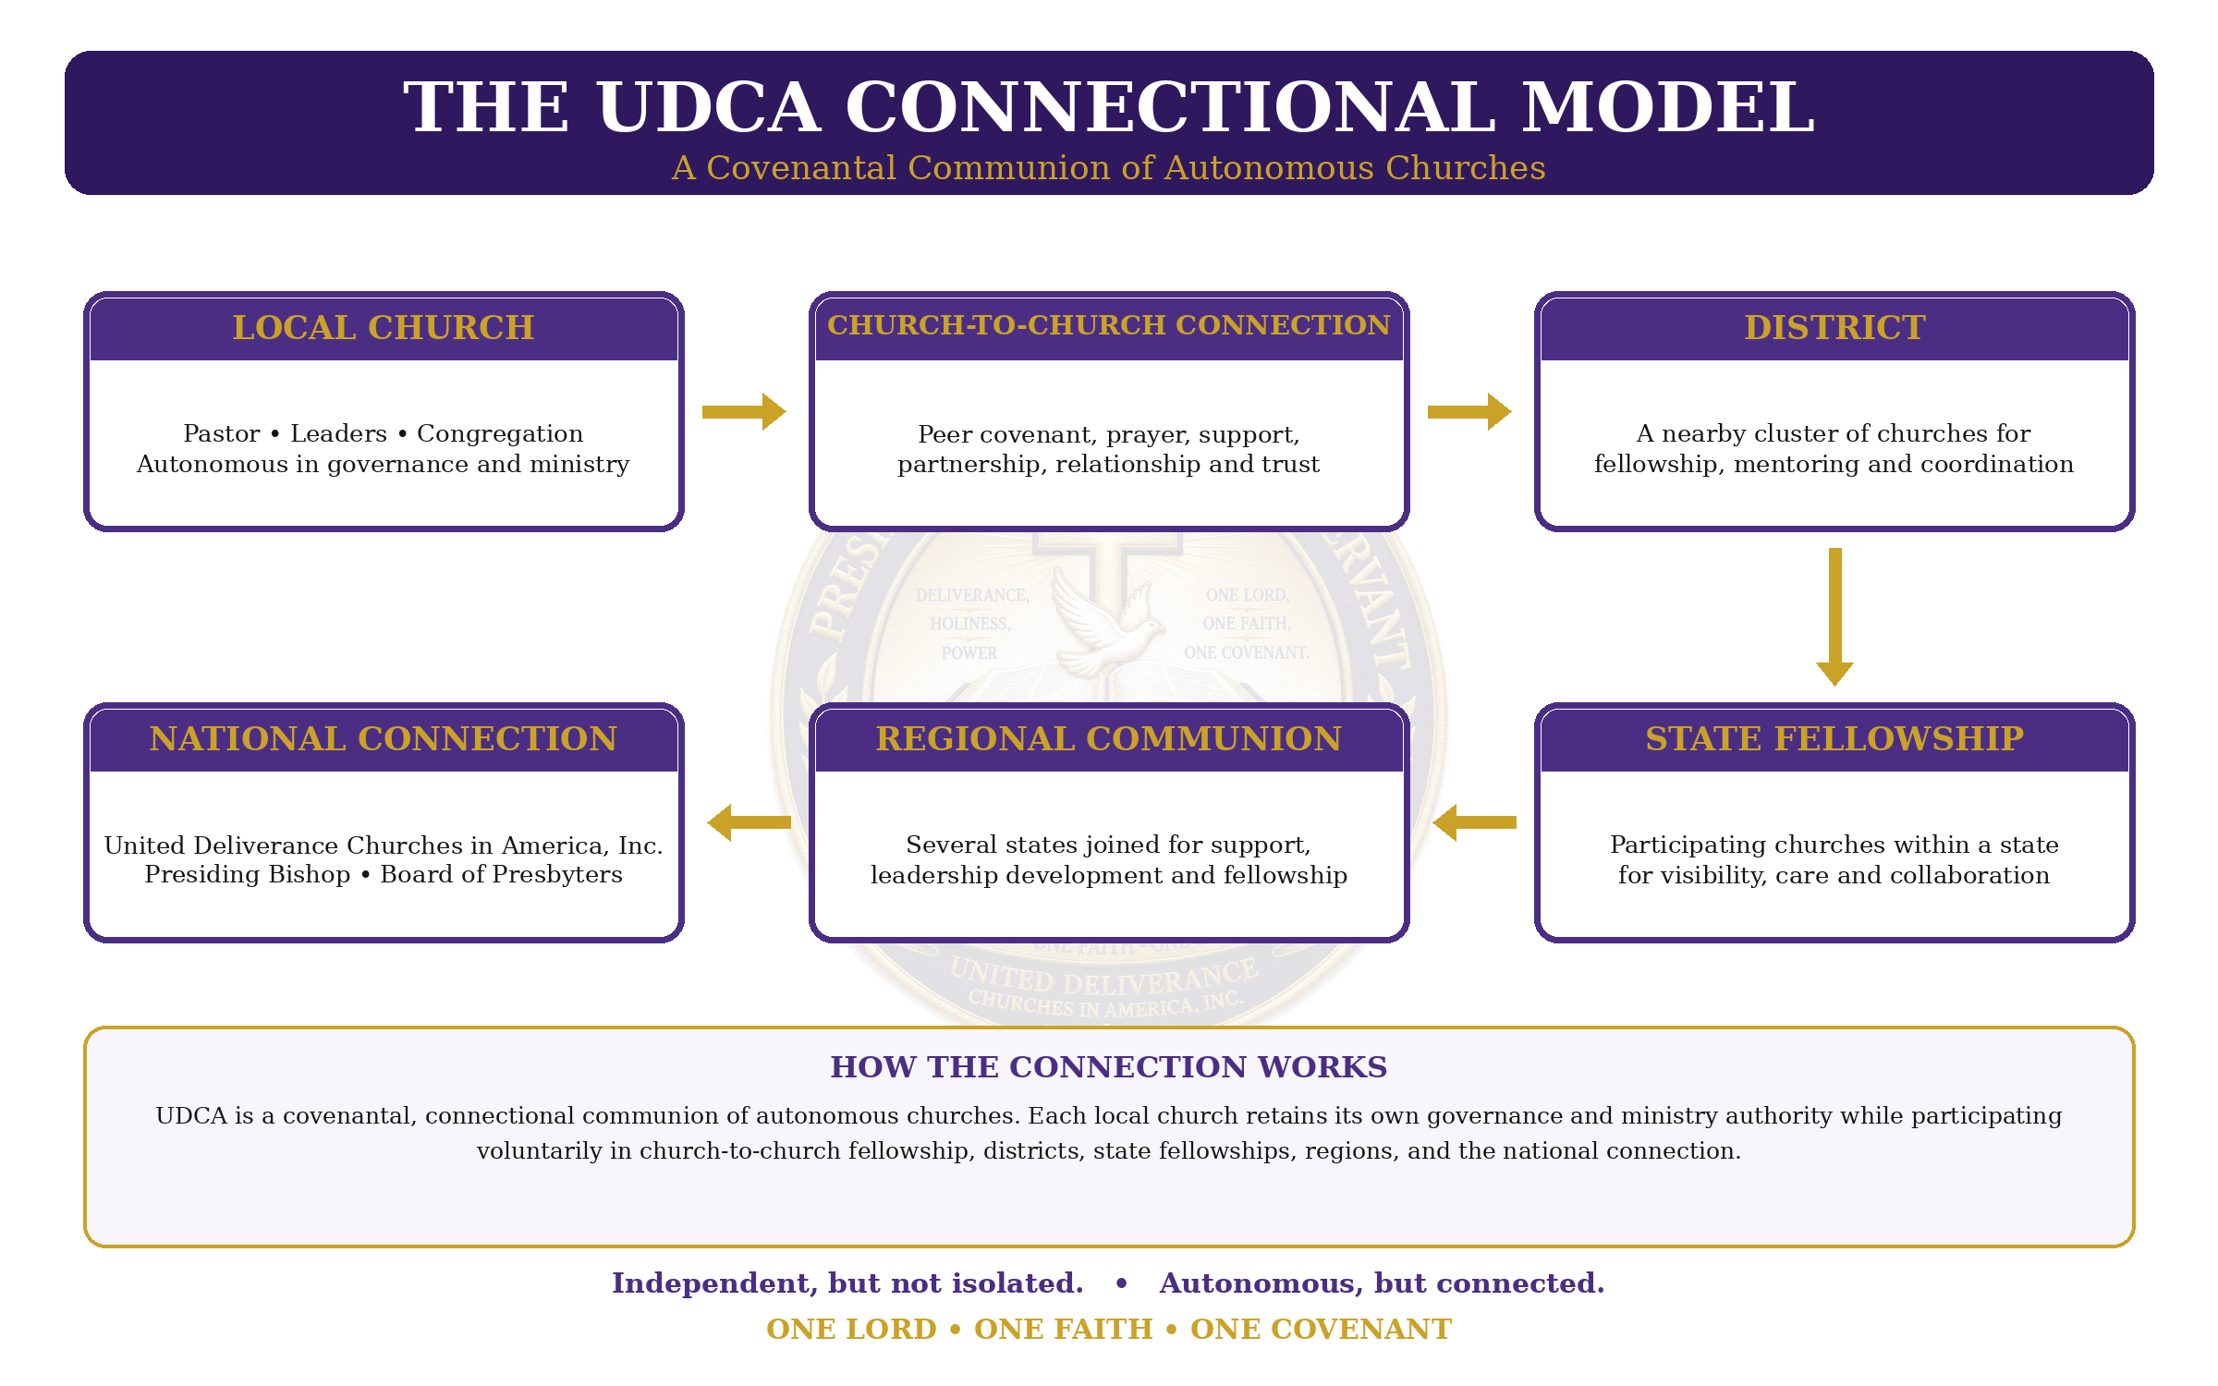

Regional Directory Index
Northeast Region
CT (8) • MA (2) • RI (1) • NY (9) | Total: 20
Mid-Atlantic Region
NJ (3) • PA (14) • MD (6) • VA (6) • WV (1) | Total: 30
Southeast Region
NC (12) • SC (2) • GA (12) • FL (12) | Total: 38
South Central & Gulf Region
AL (9) • TN (4) • KY (1) • LA (1) • TX (13) • OK (1) | Total: 29
Great Lakes & Midwest Region
OH (2) • MI (9) • IN (1) • IL (2) • WI (1) • MN (1) | Total: 16
West & Pacific Region
CA (4) • ID (1) • MT (1) • WA (1) • GU (1) • MP (1) | Total: 9
Churches are listed within each region by state, then city, then church name. Sparse state fields are kept inside their region rather than being separated onto individual state pages.

Directory Status Notice
This Regional Edition is compiled from the current UDCA active church research list. It is a connectional and outreach directory of independent Deliverance, Holiness, and Deliverance-Holiness congregations. Inclusion in this directory should not, by itself, be read as confirmation of formal UDCA membership, covenant execution, ecclesiastical appointment, or denominational affiliation. Churches on review or hold status and churches identified with conflicting denominational, network, or organizational affiliations are not included.
Active Churches | 142
Regions | 6
States / Territories Represented | 31
Edition | September 2026

NORTHEAST REGION
20 Active Churches
CT 8 • MA 2 • RI 1 • NY 9

CT — 8 Churches
Church | City | Leader | Mailing Address | Contact
House of God Outreach & Deliverance Ministries, Inc | Bridgeport |  | 500 Pequonnock St  Bridgeport, CT 06604 | (203) 333-5778  houseofgodoutreach@gmail.com  http://houseofgodoutreach.com/
Power and Mercy Deliverance Ministries | East Hartford | Bishop O'Neal A. Christie | 135 Burnside Ave Ste A1  East Hartford, CT 06108 | (866) 212-3623  nealchristie@gmail.com
Faith Healing & Deliverance Ministries | Hamden | Sanda Jelferson | 60 Connolly Pkwy  Hamden, CT 06514 | 203-288-0066  faithhealing05@gmail.com
Harvest Deliverance Ministries | Manchester | Sidney | 296 Porter St  Manchester, CT 06040 | (860) 214-2282  nhdm@verizon.net
New Gethsemane Deliverance Outreach Ministry | Meriden | DrRev Ethel Banks Graham | 220 Colony St  Meriden, CT 06451 | (203) 237-3946  ethelgraham@gmail.com
Kingdom Deliverance Ministries | New Haven | Thompson Jr. | 680 Dixwell Ave  New Haven, CT 06511 | (203) 624-5464  kdministries2007@gmail.com
Tabernacle Deliverance Praise Ministrie | Norwich | Tabitha Johnson | 230 Hunters Rd  Norwich, CT 06360 | (860) 383-2593  jtabitha@gmail.com
Deliverance Center WRLD Ministries | Stamford | Adrian St.Hill | 29 Grove St  Stamford, CT 06901 | (203) 325-9371  wdminorg@gmail.com

MA — 2 Churches
Church | City | Leader | Mailing Address | Contact
Power House Deliverance Temple | Boston |  | 106 Crawford St  Boston, MA
International Lighthouse For Deliverance Church, Inc. | Natick |  | Natick, MA | 978-836-4686  https://www.ilfdc.org/

RI — 1 Church
Church | City | Leader | Mailing Address | Contact
True Holiness Church in Christ Jesus | Providence | S. Kwame Rice (corporate president) | 788 Eddy Street  Providence, RI 02905

NY — 9 Churches
Church | City | Leader | Mailing Address | Contact
Holy Ghost Prayer House Deliverance Ministry | Bronx | Marcia Cameron Allen | 771 Burke Ave  Bronx, NY 10467 | 718-405-7596  info@holyghostprayerhouse.org  https://www.holyghostprayerhouse.org/
St. Peters Deliverance Ministries | Bronx | Edgehill | 937 Home St  Bronx, NY 10459 | 212-518-6803  st.petersdelmin@gmail.com
Good Life Deliverance Ministries | Brooklyn | JUlian Blance | 5011 Church Ave  Brooklyn, NY 11203 | 718-342-1565  goodlifechurchave717@gmail.com
Rescue The Perishing Deliverance Ministries | Brooklyn | Gregory Mitchell | 1264 Flatbush Avenue  Brooklyn, NY 11226 | 9546461017  Chambers7744@outlook.com  www.rtpdm.org
Glorified Deliverance Outreach Ministries | Cambria Heights | Mary H. Ray | 225-18 Linden Blvd  Cambria Heights, NY 11411 | 3742175970  glorifieddeliverance@gmail.com
Deliverance Tabernacle Church | Jamaica |  | 14401 Sutter Ave  Jamaica, NY 11436 | 718-529-5070
God's House of Deliverance Holiness Ministries Inc. | New York | Joel Thomas | 648 East 51 Street  New York, NY 11203 | 347-983-3279  ghodhcbrooklyn@gmail.com
Rock of Holiness Deliverance Ministry | New York | Richard G. McKenzie Sr | 2096 Nostrand Ave  New York, NY 11210 | 718-421-2205  richardmckenzie@gmail.com  http://www.rockofholiness.org/
PowerHouse Faith & Deliverance Ministries | Yonkers | John Felder | 365 Palmer Road  Yonkers, NY 10701 | 914-361-5154  phfdm@powerhousefd.org  https://powerhousefd.org/

MID-ATLANTIC REGION
30 Active Churches
NJ 3 • PA 14 • MD 6 • VA 6 • WV 1

NJ — 3 Churches
Church | City | Leader | Mailing Address | Contact
Promise of Deliverance Ministries | Camden |  | 325 Market St.  Camden, NJ 08102 | 609 289 7793  promiseofdeliverance@gmail.com  https://www.promiseofdeliverance.org/
In The Name of Jesus Healing and Deliverance Ministries | Newark | Clifton Williams | 307 16th Avenue  Newark, NJ 07108 | 973-573-6817  1inthenameofjesus@gmail.com  1inthenameofjesus.business.site
Christ Divine Healing and Deliverance Ministry | Union | Jacob Afere | 3 Monroe St N  Union, NJ 07083 | 908-687-7900  cdhdadm@gmail.com  http://christdivinehealing.org

PA — 14 Churches
Church | City | Leader | Mailing Address | Contact
Word of Faith Outreach & Deliverance Ministries, Inc | Darby | Patricia E.Lampkin | 21 Main St  Darby, PA 19023 | 484-494-1755  wof19023@gmail.com
Divine Direction Deliverance Ministries | East Stroudsburg | Timothy Sturrup | 528 Seven Bridge Rd Unit 100B  East Stroudsburg, PA 18301 | 570-517-9971  divinedirection127@yahoo.com
Candlelight Deliverance Ministries | Philadelphia | NELSON GOLL | 7111 Woodland Avenue  Philadelphia, PA 19142 | (267) 339-9537  nelson@gmail.com
Deliverance Tabernacle Church | Philadelphia |  | 6130 Wister St  Philadelphia, PA 19138 | 215-438-5184
Gospel of Deliverance Church | Philadelphia |  | 558 W Wyoming Ave  Philadelphia, PA 19140 | 215-457-2028
Greater Agape Deliverance International Ministries Inc | Philadelphia | Nate Floyd | Ne 15th Dauphin St  Philadelphia, PA 19132 | (215) 266-1645  natefloyd@gmail.com
Healing Fire Deliverance Ministries | Philadelphia | Francina Jones | 2308 N Broad St box 20590  Philadelphia, PA 19132 | (866) 535-9380  francinajones@gmail.com
New Hope Church of Deliverance | Philadelphia |  | 1300 S 22nd St  Philadelphia, PA 19146 | 215-389-1521
Total Deliverance Ministry | Philadelphia | Bishop Avery Austin, | 2201 W Norris St  Philadelphia, PA 19121 | (267) 639-4698
Watch God Move Deliverance Ministries | Philadelphia | Dr. Kris Halsey | 7013 Torresdale Avenue  Philadelphia, PA 19135 | 267-538-5018  info@watchgodmove.org  http://www.watchgodmove.org/
We Are More Than Conquerors Deliverance Ministries | Philadelphia | Anthony Ferguson | 111 S 63rd St  Philadelphia, PA 19139 | (215) 471-3985  anthonyferguson@gmail.com
Emmaus Deliverance Ministries | Pittsburgh | Emmaus Cathedral | 2704 Delgar St  Pittsburgh, PA 15214 | (412) 322-8907  cathedral@gmail.com
Kings Deliverance Holiness Church | Vandergrift | Theresa Jones | 7 Custer Ave  Vandergrift, PA 15690 | (724) 568-1552  theresa.jones@gmail.com  https://kings-deliverance-holiness-church-pa.hub.biz/
Antioch Outreach and Deliverance Ministry | Wayne | Bishop Chance Sr. | 175 Strafford Ave  Wayne, PA 19087 | (484) 588-0448  antiochoutreachministries1@gmail.com

MD — 6 Churches
Church | City | Leader | Mailing Address | Contact
Holy Temple Holiness Church of Deliverance | Baltimore | James Tilghman Jr. / Senior Pastor Greta Tilghman | 2016 West Pratt Street  Baltimore, MD 21223 | (410) 233-7334  admin@holytemplenation.org  https://holytemplenation.org/
Holy Temple Holiness Church of Deliverance - East | Baltimore | Margaret Shelley | 336 E 25th St  Baltimore, MD 21218 | 410-258-5594  margaretshelley@me.com  http://HolyTemple.church/
King's Deliverance Holiness Church, Inc. | Baltimore | Martin E jones | 1200 N Fulton Ave  Baltimore, MD 21217 | 667-212-3879  martinjones@gmail.com
New Hope Church of Deliverance | Baltimore |  | 6218 Reisterstown Rd  Baltimore, MD | 410-764-0566
Salvation Outreach & Deliverance Ministries Inc | Temple Hills | David Ibiyeomie | 4598 Beech Rd  Temple Hills, MD 20748 | (301) 423-1505  dibiyeomie@gmail.com
Bethel Deliverance Outreach Ministries | Upper Marlboro | Alonzo M. Walker Sr. | 10675 Crain Hwy  Upper Marlboro, MD 20772 | (301) 782-1795  walonzo@gmail.com  https://www.bdomchurch.org/

VA — 6 Churches
Church | City | Leader | Mailing Address | Contact
Deliverance Tabernacle Church | Chesapeake | Dr. Steven V. Terry | 4202 Bainbridge Boulevard  Chesapeake, VA 23324 | 757-625-4977 / 757-625-1875
True Way Deliverance Holiness Church | Danville | Sue Robinson | 821 Oak Crest Rd  Danville, VA 24540 | (434) 792-1120  suerobinson@gmail.com
New Holy Deliverance Temple Outreach Ministry | Martinsville | Barbara Hairston / Lisa King | 6274 Al Philpott Hwy  Martinsville, VA 24112 | 276-632-0912
Community Fellowship of Deliverance | Portsmouth | Russell Smith II / Elnora Smith | 519 Williamsburg Ave  Portsmouth, VA 23704 | 757-510-2940
Holy Light Church of Deliverance | Portsmouth | Pastor Dorene C. Norris / Bishop Samuel L. Carruth | 1918 Lincoln St  Portsmouth, VA 23704 | 757-397-4424  holylightva@gmail.com  https://holylightchurchofdeliverance.org/
The Divine Church of Deliverance and Transformation Holiness | Suffolk | Brian E. Outlaw | 6315 Whaleyville Blvd  Suffolk, VA 23438 | 757-679-0909  http://www.tdcdtholiness.org/

WV — 1 Church
Church | City | Leader | Mailing Address | Contact
Kingdom Purpose Deliverance Church | Martinsburg |  | 124 N High St  Martinsburg, WV 25404 | (304) 262-4002

SOUTHEAST REGION
38 Active Churches
NC 12 • SC 2 • GA 12 • FL 12

NC — 12 Churches
Church | City | Leader | Mailing Address | Contact
Deliverance Temple Holiness Church | Ayden |  | 4043 Laurinburg street  Ayden, NC 28513 | 252-617-2830
Miracle Temple Deliverance Ministries | Burgaw | James Bryant | 401 N Wright St  Burgaw, NC 28425 | 910-259-3388  jamesbryant.mtdm@gmail.com  https://www.mtdm.org/
Higher Praise Deliverance Ministries | Charlotte | Reginald & LaKiesha Coffey / Emma White | 7561 Orr Rd  Charlotte, NC 28213 | 877-579-1299
Potter's House Deliverance Center | Fayetteville | Sandy L. Owens | 583 S Reilly Rd  Fayetteville, NC 28314 | 910-568-1431
Deliverance-Faith Holiness Church | Greenville |  | Evans St  Greenville, NC 27834 | (252) 551-0559
New Deliverance Holy Church Ministries#2 | Greenville | White Robes | 1404 West 14th Avenue  Greenville, NC 27834 | (252) 329-0711  white.robes@gmail.com
Holy Deliverance Temple Church | Hamlet |  | 114 Raleigh St  Hamlet, NC 28345 | 910-582-8728
Temple of Deliverance Worship Center | Kinston | Pastor Robert Brown / Lorraine Brown | 314 West Lenoir Avenue  Kinston, NC 28501
Faith Hope Deliverance Christian Center | Sanford | Leon Fogle Sr. / Nadine Michelle Fogle | 646 Oakwood Ave  Sanford, NC | 919-777-6027
Royal Light Holiness Church of Deliverance | Tillery |  | Hwy 561 West  Tillery, NC 27874 | 252-826-5831
Christ Deliverance Tabernacle Ministries Inc. | Wilson | Dr. Amanda | 413 Pender St E  Wilson, NC 27893 | (252) 281-1112  cdtminc@gmail.com  https://www.cdtminc.org/
House of Praise and Deliverance | Wilson |  | 1107 Walnut St  Wilson, NC 27893 | 252-291-0663

SC — 2 Churches
Church | City | Leader | Mailing Address | Contact
True Holiness Church of Deliverance-Kingstree | Kingstree | Lady Deidre Giles | Kingstree, SC 29556 | 843-617-2330  Ladygiles63@gmail.com
Deliverance Holiness Church | Lancaster | Dennis Miller | 205 Norland Ln  Lancaster, SC 29720 | 803-462-4545  dennismiller@gmail.com

GA — 12 Churches
Church | City | Leader | Mailing Address | Contact
Holy Deliverance Church | Atlanta |  | 3462 Delmar Ln NW  Atlanta, GA 30331 | 404-472-0070
Faith Holiness Healing Deliverance Ministry | Columbus | John Glass | 407 Wilton St  Columbus, GA 31904 | (706) 351-4807  sozo.faithalive@gmail.com
Brazeal Chapel Holiness Church | East Dublin |  | 1440 Brazeal Cir  East Dublin, GA 31027 | https://www.brazealchapel.com/
Victory Deliverance Holiness Church | Fort Valley | Willie F. Smith | 432 Wye St  Fort Valley, GA 31030 | (478) 825-3456  willie.smith@gmail.com
Faith and Deliverance Ministries | Mableton | Bishop Donald Johnson / Sarah Johnson | 1067 Veterans Memorial Hwy SW  Mableton, GA | 678-451-0180
Deliverance Tabernacle Holiness Church 2 | Macon | Dr. Gail Bailey | 1689 Anthony Rd  Macon, GA 31204 | (478) 781-0077  gbailey@gmail.com
Miracle Healing Deliverance Holiness Church | Macon | Cornell Johnson | 1710 Nussbaum Ave  Macon, GA 31201 | (478) 738-0910  johnsonc@gmail.com
Deliverance of Faith Ministers | Smyrna |  | 1717 Spring St SE  Smyrna, GA 30080 | 770-434-0400
Atlanta Deliverance Evangelistic Ministries | Stone Mountain | Rev. Harold J. Krause / Janice Krause | 5355 Stone Mountain Hwy  Stone Mountain, GA | 770-776-6854
Trials of Faith Deliverance Holiness Church | Vienna | Desmond Sharpe Sermon | 632 W Pine St  Vienna, GA 31092 | (229) 268-8305  Sharpes@gmail.com
Deliverance Tabernacle Holiness Church | Warner Robins | Dr. Gail Bailey | 435 Elberta Rd  Warner Robins, GA 31093 | (478) 328-0514  dthchurch1@aol.com
Faith Deliverance Holiness Church | Zebulon | Joe J. Winter | 440 Meansville St  Zebulon, GA 30295 | (770) 567-9572  jwinter@gmail.com

FL — 12 Churches
Church | City | Leader | Mailing Address | Contact
The Real Praise Temple Church. A Deliverance Ministry. | Bartow | Bishop Willie Watson Jr. | 1010 Britts Lane  Bartow, FL 33830 | 863-533-9332
Tabernacle of Deliverance Ministries | Bunnell | Terry Brown | 07 E Booe St  Bunnell, FL 32110 | 386-313-5958  tabministry@hotmail.com
Evangelist Deliverance Holiness church | Fort Pierce | BERNARD | 1611 N 17th St  Fort Pierce, FL 34950 | (772) 408-6758  pastor09@comcast.net  www.edhchurch.org
New Life Deliverance Ministries, Inc. | Havana | Jacquelyn C. Porter | 14 Sierra Rd  Havana, FL 32333 | 850-616-5050  nldmtally@att.net  https://www.nldministries.org/
Under The Blood Deliverance Holiness Church | Mulberry | ROSA L NORMAN | 200 NW 5th Ave  Mulberry, FL 33860 | (863) 425-8013  rosa.norman@gmail.com
Grace and Truth Deliverance Ministries Inc. | Palatka | Jervey | 700 N 11th St  Palatka, FL 32177 | 386-328-1479  graceandtruth1@bellsouth.net
New Hope Holiness with Deliverance Ministries | Palmetto | Tamar Gibson | 516 30th Street East  Palmetto, FL 34221 | 941-723-2893  n.holiness@gmail.com
Abundant Life Deliverance Ministries Center Inc. | Pembroke Pines | Robert J. Wimberly Sr | 100 S Douglas Rd  Pembroke Pines, FL 33025 | (954) 963-6907.
Deliverance Christian Connection Ministry | Riverview | Pastors James & Angela Scruggs | 10030 Mathog Rd  Riverview, FL | 813-401-7223
True Holiness Deliverance Tabernacle | Sanford | Pastor Ronald Nathan | 950 Historic Goldsboro Blvd  Sanford, FL 32771 | 407-322-4070  https://thdt.org/
Deliverance Outreach Holiness | Tampa | Bernard L. Giles | 3010 N 46th St  Tampa, FL 33605 | (813) 626-0343  hdoministry@gmail.com
Faith & Deliverance Ministry Inc. | Vero Beach | Tiffany Joyce Ealy / Dewey James Hendrix IV | 683 27th Avenue SW  Vero Beach, FL 32968 | (772) 217-8191

SOUTH CENTRAL & GULF REGION
29 Active Churches
AL 9 • TN 4 • KY 1 • LA 1 • TX 13 • OK 1

AL — 9 Churches
Church | City | Leader | Mailing Address | Contact
Holiness Deliverance Tabernacle | Adger | Ronald McKnight | 7620 Main St  Adger, AL 35006 | 205-428-1325  ronaldmcknight@gmail.com
True Deliverance Holiness Church | Auburn | Nolan Torbert | 936 North Donahue Drive  Auburn, AL 36832 | 334-502-4700  avministry936@yahoo.com  https://www.tdhcinfo.org/
Stone Deliverance Temple | Bay Minette | Co-Pastor Augie Locke | 820 Dr Martin Luther King Blvd  Bay Minette, AL 36507 | 251-454-7650
Purity Deliverance Holiness Church | Birmingham | Carrie M Purdom | 5005 Cheek Road  Birmingham, AL 35207 | 205-841-2004  info@pdeliverancehc.org  http://pdeliverancehc.org/
Faith Deliverance Holiness Church | Elmore |  | 475 Jackson St  Elmore, AL 36025 | 334-567-9209
Divine Deliverance Ministries | Huntsville | Jaay Jordan | 1200 Jordan Lane NW, Suite 8  Huntsville, AL 35816 | (256) 361-9284  ddmin@yahoo.com  https://ddmin.website/
True Praise Deliverance Tabernacle Holiness Church | Mobile |  | 2743 Mill St  Mobile, AL 36607 | (251) 478-6882
TRUE DELIVERANCE HOLINESS CHURCH – COMMUNITY CENTER | Opelika | Artis Johnson | 500 26th St North  Opelika, AL 36801 | (678) 915-2110  info@third-lens.org  https://www.third-lens.org/true-deliverance-holiness-church-community-center-auburn-al/
Temple of Deliverance Holiness Church | Wetumpka |  | 620 Alabama St  Wetumpka, AL 36092 | (334) 514-3114  https://temple-of-deliverance-holiness-church.hub.biz/

TN — 4 Churches
Church | City | Leader | Mailing Address | Contact
gates of deliverance holiness church | Jackson | Bro. David Terrell | 607 Love Road  Jackson, TN 38301 | 918-652-1579  gatesofdeliverance@yahoo.com  https://gatesofdeliverance.wixsite.com/
Abundant Life Deliverance Ministry | Memphis | Vickie | 66 East Bodley Ave  Memphis, TN 38109 | 901-308-0659  aldcministries@gmail.com  http://www.abundantlifedeliverancechurch.org/
Greater Revelation Temple Deliverance Holiness Church | Memphis |  | 3638 Huckleberry St  Memphis, TN 38116
Prayer House Of Deliverance Holiness Church | Memphis | Eric D. Reynolds | 1113 Mcclure Rd  Memphis, TN 38116 | (901) 363-2096  ericreynolds@gmail.com

KY — 1 Church
Church | City | Leader | Mailing Address | Contact
Holiness Church Of Deliverance | Hopkinsville | Lyndia Kennebrew | 351 North Dr  Hopkinsville, KY 42240 | (270) 886-1660

LA — 1 Church
Church | City | Leader | Mailing Address | Contact
Miracle Deliverance Holiness Church | Sulphur | Belinda Barber | 3940 E Burton St  Sulphur, LA 70663 | (337) 625-1166  belindab@gmail.com

TX — 13 Churches
Church | City | Leader | Mailing Address | Contact
United Holiness Deliverance Temple - Atlanta | Atlanta | Barbara Pinson | 615 N. Louise St  Atlanta, TX 75551 | 430-562-7141  uhdtchurch@gmail.com  https://atlantauhdt.com/
New Life Deliverance Holiness Church | Beaumont | Pastor Leon Campbell | 4185 Magnolia St  Beaumont, TX 77703 | 409-328-8006
Deliverance Outreach Ministries | Dallas | Barbara Ezell | 1003 S Cockrell Hill Rd  Dallas, TX 75116 | 478-967-2709  cesr@bellsouth.net  http://www.deliveranceoutreachchurch.com/
Deliverance Revival Tabernacle Holiness Church | Dallas | Minister Frank Turner TI | 3200 Bainbridge Ave  Dallas, TX 75237 | (972) 709-9399  https://www.faithstreet.com/church/deliverance-revival-tabernacle-holiness-church-dallas-tx
God's Hospital Deliverance Holiness Church | Dallas | Bishop Herbert Smith | 1223 Grant St  Dallas, TX 75203 | 214-942-0074  bishopsmith340@tx.rr.com  http://www.godshospitalchurch.com
House Of Hope Prayer and Deliverance Ministry | Dallas | Lesley Colon | 1140 Empire Central Pl Ste 106h  Dallas, TX 75247 | 469-579-7240  houseofhopeanddeliverance@hotmail.com
Christ Deliverance Holiness Church | Houston | Rodney C. Pitre (public nonprofit contact) | 11311 Bethnal Green Dr  Houston, TX 77066
Houston Deliverance Center | Houston | Dr. Aaron M. Jones / Renee Jones | 4025 Griggs Rd  Houston, TX 77021 | 713-842-6050
Miracle Deliverance Holiness Church | Houston | Pastor Belinda Barber | 701 Nadolney St  Houston, TX 77015 | (713) 451-0536  belindabarber@gmail.com
New Day Deliverance Holiness Church | Houston | Apostle Richard Taylor | 9001 Mesa Drive  Houston, TX 77028 | 713-633-5011  nddhc@newdaychurch.org  https://www.newdaychurch.org/nddhc/
New Deliverance Fellowship Ministries, Inc. | Houston | Kenneth Stringfellow / Debra Stringfellow | 6602 Martin Luther King Jr Blvd  Houston, TX 77033 | 832-887-6745  debstring@aol.com; Bishopkenstring@gmail.com  https://ndfministries.org/
Deliverance Temple Holiness Church | Plano | Kevin Holt | 3269 Independence Pkwy  Plano, TX 75075 | 214-477-9911  deliverancetemplehc@yahoo.com
DayStar Deliverance Ministries | Richardson | Eric L Hawthorne | 635 W Campbell Rd, Ste 201  Richardson, TX 75080 | 972-480-0200  info@daystardm.org  http://www.daystardm.org/

OK — 1 Church
Church | City | Leader | Mailing Address | Contact
Deliverance Ministries, Inc. | OKLAHOMA | Everett Cox | 2515 NW 16th St.  OKLAHOMA, OK 73107 | (405) 842-5509  ecox@delmin.org  https://delmin.org

GREAT LAKES & MIDWEST REGION
16 Active Churches
OH 2 • MI 9 • IN 1 • IL 2 • WI 1 • MN 1

OH — 2 Churches
Church | City | Leader | Mailing Address | Contact
Stone Deliverance Evangelical Temple | Akron | Pastor Mary L. Stone | 595 Copley Rd  Akron, OH 44320 | 330-258-8129
Word of Deliverance Ministries for the World, Inc. | Forest Park | Bishop Bobby Hilton | 693 Fresno Road  Forest Park, OH 45240 | 513-851-9673  info@wordofdeliverance.org  http://www.wordofdeliverance.org/

MI — 9 Churches
Church | City | Leader | Mailing Address | Contact
God's Vineyard Deliverance Ministries | Center Line | Ezekiel Alawale | 8090 Theisen  Center Line, MI 48015 | (586) 755-8910  ezekielalawale@gmail.com
Ark-God Deliverance Ministries | Detroit | Stephanie Jones | 18490 Annchester Rd  Detroit, MI 48219 | (313) 533-0609  jstephanie@gmail.com
Christ Hope of Glory Deliverance Ministries & Grace & Truth Deliverance Church | Detroit | Clinton Charls Braynet | PO Box 21855  Detroit, MI 48221 | (313) 570-2314  braynet@gmail.com
Divine Deliverance Ministries | Detroit | Jaay | 479 Algonquin St  Detroit, MI 48215 | (313) 331-2306  Jaay@gmail.com  https://ddmin.website/
Greater Shiloh Deliverance Ministries | Detroit | Melvin Keith Jenkins | 19803 Joy Rd  Detroit, MI 48228 | 313) 909-2699  gsdministries99@gmail.com  https://www.greatershilohdeliveranceministries.com/
New Deliverance Ministry International | Detroit | Travis Mason | 12490 Kelly Rd  Detroit, MI 48224 | (313) 458-7492  tmason@gmail.com
Greater Deliverance Ministries | Flint | Hardin Mighty | 1352 N Chevrolet Ave  Flint, MI 48504 | (810) 766-1430  mhardin@gmail.com  https://greaterdeliveranceministries1.com
Voice Of Power Deliverance Ministry | Lansing | Damon Milton | 1033 Hickory St  Lansing, MI 48912 | 517-763-2880  vopdm@yahoo.com  http://vopdm.org/
Wings of Deliverance Transforming Ministries | Lincoln Park | Pastor Karen | 2984 Fort St  Lincoln Park, MI 48146 | (313) 381-6090  wingsofdeliverancetm@yahoo.com  https://hymnsforthehomeless.net/

IN — 1 Church
Church | City | Leader | Mailing Address | Contact
Open Gate Phrase & Deliverance Ministries | Elkhart | Wayne Malone | 422 W High St  Elkhart, IN 46516 | (574) 522-8250  waynemalone@gmail.com

IL — 2 Churches
Church | City | Leader | Mailing Address | Contact
Evangelistic Outreach Deliverance Ministry | Chicago | Dr. Teresa A. Moton | 4300 W Madison St  Chicago, IL 60624 | (773) 378-6344  eodministries4alabama@gmail.com
Deliverance Gospel Tabernacle | Springfield | Matthew Sogunro | 1805 E Laurel St  Springfield, IL 62703 | (217) 528-5474  sogunro@gmail.com  http://www.deliverancegospelchurch.org/

WI — 1 Church
Church | City | Leader | Mailing Address | Contact
Faith Builders of Deliverance Holiness Church | Racine | Tara Campbell | 1913 Taylor Avenue  Racine, WI

MN — 1 Church
Church | City | Leader | Mailing Address | Contact
True Deliverance Outreach Ministry-MN | South Saint Paul | Shirley Ard | 185 Concord St N  South Saint Paul, MN 55075 | (651) 226-8003  shirleyard@gmail.com

WEST & PACIFIC REGION
9 Active Churches
CA 4 • ID 1 • MT 1 • WA 1 • GU 1 • MP 1

CA — 4 Churches
Church | City | Leader | Mailing Address | Contact
Deliverance Temple Holiness Church | Berkeley | Mary Johnson | 1918 Blake  Berkeley, CA 94704 | (510) 845-0904  m.johnson@gmail.com
Beauty of Holiness Church of Deliverance | Carson | Bernard L. Giles | 1123 E Dominguez St Ste I  Carson, CA 90746 | (855) 312-8631  pstrmor@gmail.com
Los Angeles Holiness Church | Los Angeles |  | 3660 S. Gramercy Pl.  Los Angeles, CA 90018 | 323-733-5000  church.secretary@laholiness.com  https://laholiness.com/
Holy Spirit Of Deliverance Ministries | Rialto | Wendell Shaw | 728 E Foothill Blvd  Rialto, CA 92376 | 989-312-3221  holyspiritstaynearit@gmail.com

ID — 1 Church
Church | City | Leader | Mailing Address | Contact
Calvary Holiness Church | Wilder |  | 310 B Ave  Wilder, ID 83676 | 208-936-8579

MT — 1 Church
Church | City | Leader | Mailing Address | Contact
Holiness Tabernacle | Polson | Pastor Paul Blanton (directory listing) | 48901 Hwy 93, Suite A 139  Polson, MT 59860

WA — 1 Church
Church | City | Leader | Mailing Address | Contact
Deliverance Temple Ministries | Covington |  | 24030 132nd Ave SE  Covington, WA 98042 | 253-638-1682

GU — 1 Church
Church | City | Leader | Mailing Address | Contact
Guam Evangelical Holiness Church | Yigo | Cesario Mangsat (public nonprofit contact) | 111 Chalan Balako PMB 661  Yigo, GU 96929-7103

MP — 1 Church
Church | City | Leader | Mailing Address | Contact
Saipan Evangelical Holiness Church | Saipan |  | Saipan, MP 96950

ABOUT UDCA
United Deliverance Churches in America, Inc. is a covenantal, connectional communion of independent Deliverance, Holiness, and Deliverance-Holiness churches committed to spiritual fellowship, leadership development, ministry collaboration, and a united Christian witness.
OUR MISSION | To connect, encourage, and strengthen independent Deliverance and Holiness churches through covenant, fellowship, and shared kingdom purpose.
OUR VISION | To provide a credible connectional platform through which participating churches can build relationships, share resources, develop leaders, and address common concerns while preserving local church autonomy.
FAITH • FELLOWSHIP • LEADERSHIP • SERVICE • IMPACT
“One Lord, one faith, one baptism.” — Ephesians 4:5
UNITED DELIVERANCE CHURCHES IN AMERICA, INC.
www.udcanational.org
officegeneralsec@udcanational.org
803 728-1292
Independent, but not isolated. Autonomous, but connected.
One Lord • One Faith • One Covenant

